Spiritual life  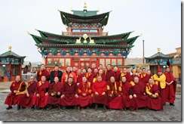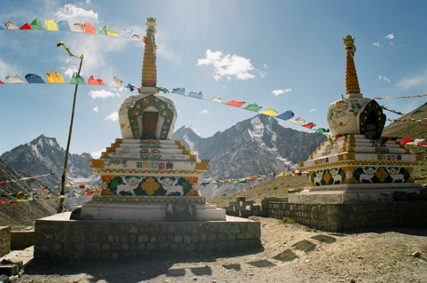  All the inhabitants in Buryatia are closely connected with religion. The basic religion of rhe locals for a long time had been shamanism, but in the 18th century 12 lamas came from Tibet. They brought their knowledge about Budda, their sacred books, founded monasteries Besides being doctors they helped the locals following the ancient tradition of Tibetan. medicine.  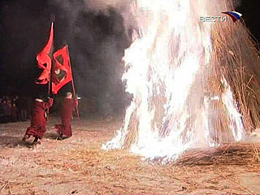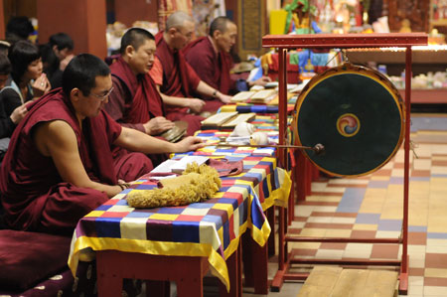  All the year round there held the religious ceremonies on different occasions. Every day in numerous datsans (Buddist temples)lamas read prayers asking for the peace and quiet for all living beings.  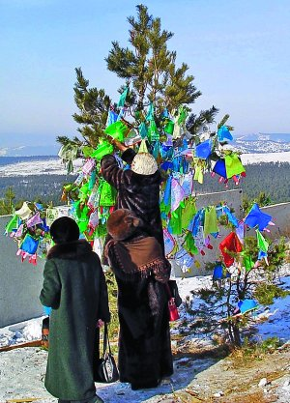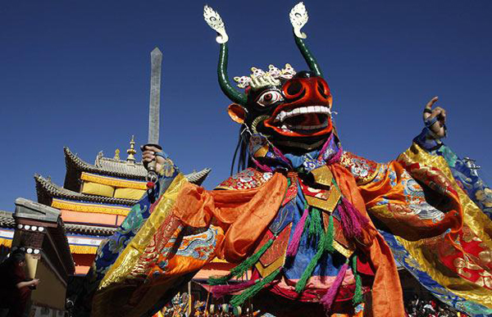 | Spiritual life  The Odigitruevsky Cathedral built in early 17th century in honor of Madonna Odigitriya. The golden carved Iconostases. In the upper temple there is an eight rows icon four stepped iconostasis.  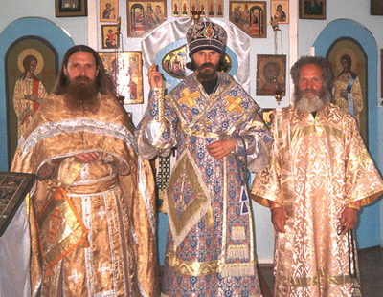  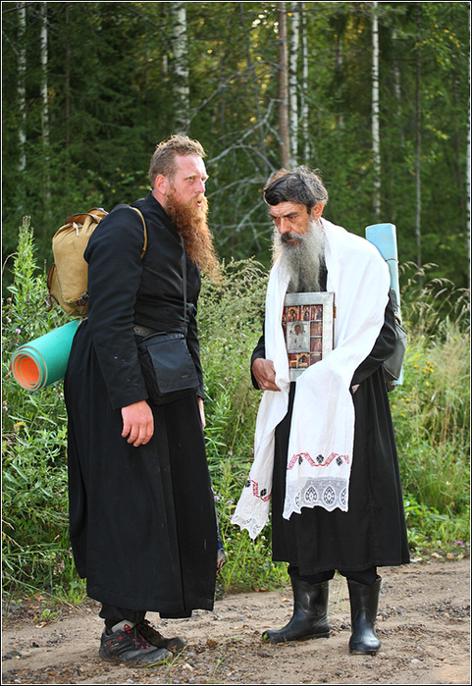  A Russian Old Believer church moved to the ethnographic museum in Ulan-Ude  The Svyato-Troitsky Cathedral. The construction of the Cathedral started in 1798 and finished in 1809 год.  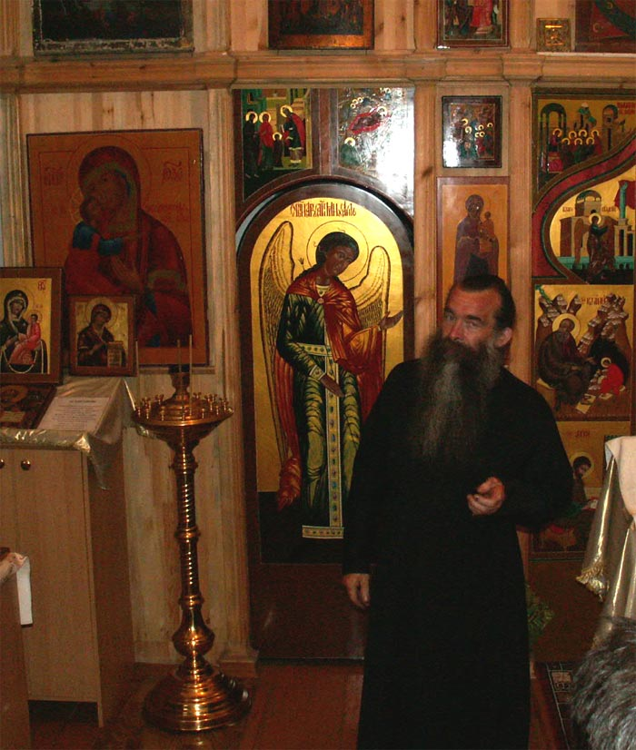  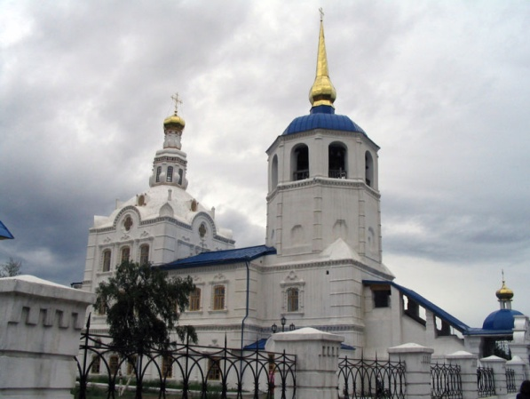  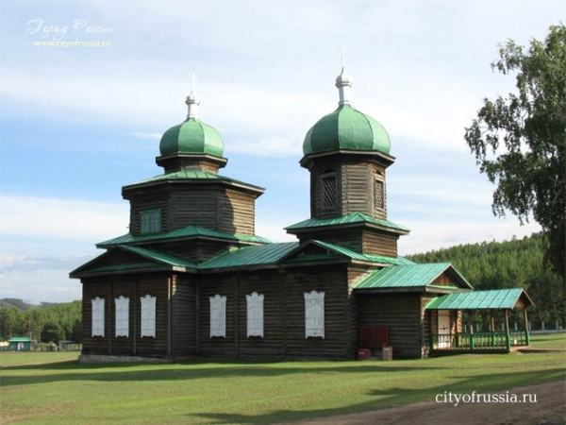  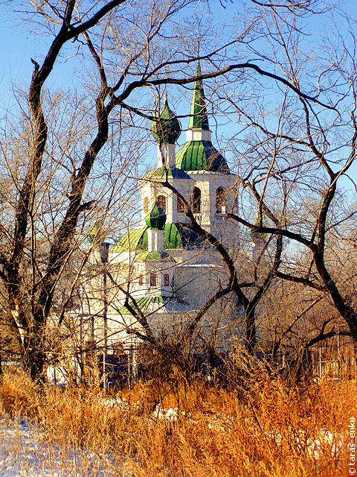
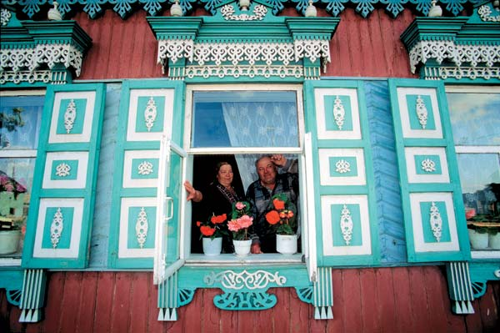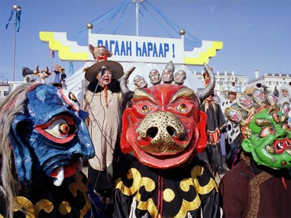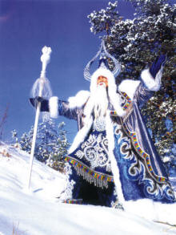  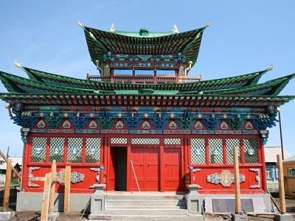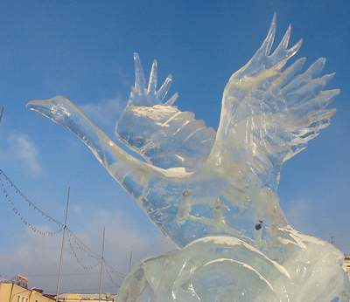  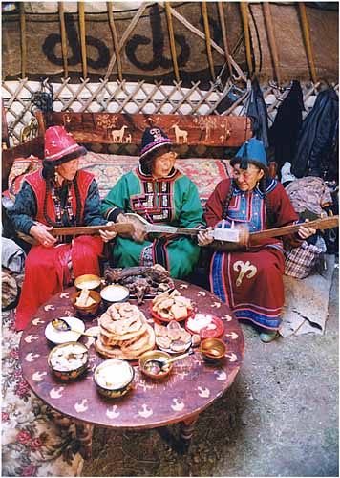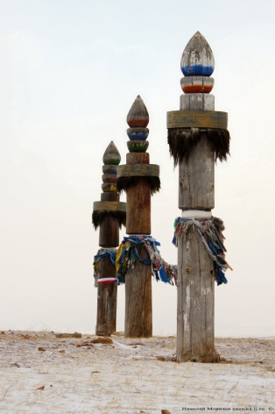  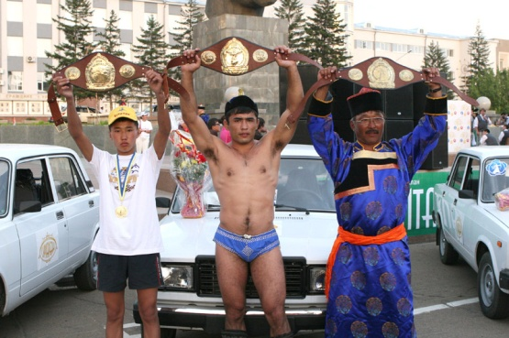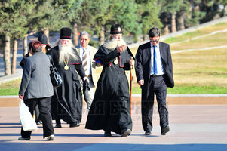 |  | Spiritual life  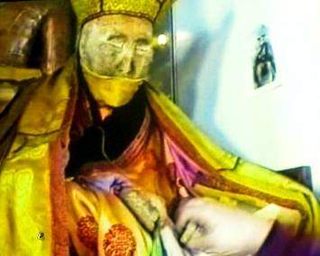  Dashi-Dorzho Itigilov (1852–1927) was a Buryat Buddhist lama of the Tibetan Buddhist tradition, best known for the lifelike state of his body, which is not subject to macroscopic decay. Itigilov left a testament asking to be buried as he was at the time of his death, sitting in lotus posture. According to his wishes, his body was put into a pine box and interred at a bumkhan (a graveyard for the lama burials) in the locality of Khukhe-Zurkhen. One of the testament clauses stipulated that his body should be exhumed by other monks within several years. This clause is interpreted by enthusiasts to demonstrate Itigilov's precognisance of his body's incorruptibility. It is said that Itigilov's body was never embalmed or mummified and that his corpse still bleeds if punctured. A report by Al Jazeera states that the body had been preserved by being packed in salt and shows recent footage of the body being removed from this salt, although the reporter is not clear about the time period in which this artificial preservation technique was first applied. The Buddhist monks approach him as a living person and shake hands with him. Some claim that Itigilov is still alive, only immersed in a hibernation- or nirvana-like state. On 23 April 2003, the Buddhist conference recognized the body of Dashi-Dorzho Itigilov as one of the sacred Buddhist objects of Russia.

